Exon case study
Camila Pazos, Emilia Goralska, Julie Prins, Yichen Yang, Maren Graberg and Alessandro Demichelis

Introduction
Exon is a manufacturer located in the Italian market, selling printers and copiers for household and corporate customers. The company is currently experiencing supply chain inefficiencies, declining demand, and increasing environmental pressure. The combination of shifting towards paperless work environments, long supply routes, and a lack of a clear end-of-life strategy challenges the company’s competitiveness and sustainability performance. This report aims to map how Exon can redesign itself to tackle these challenges.

Current network of actors
Exon’s current actor model can be summarized as follows:
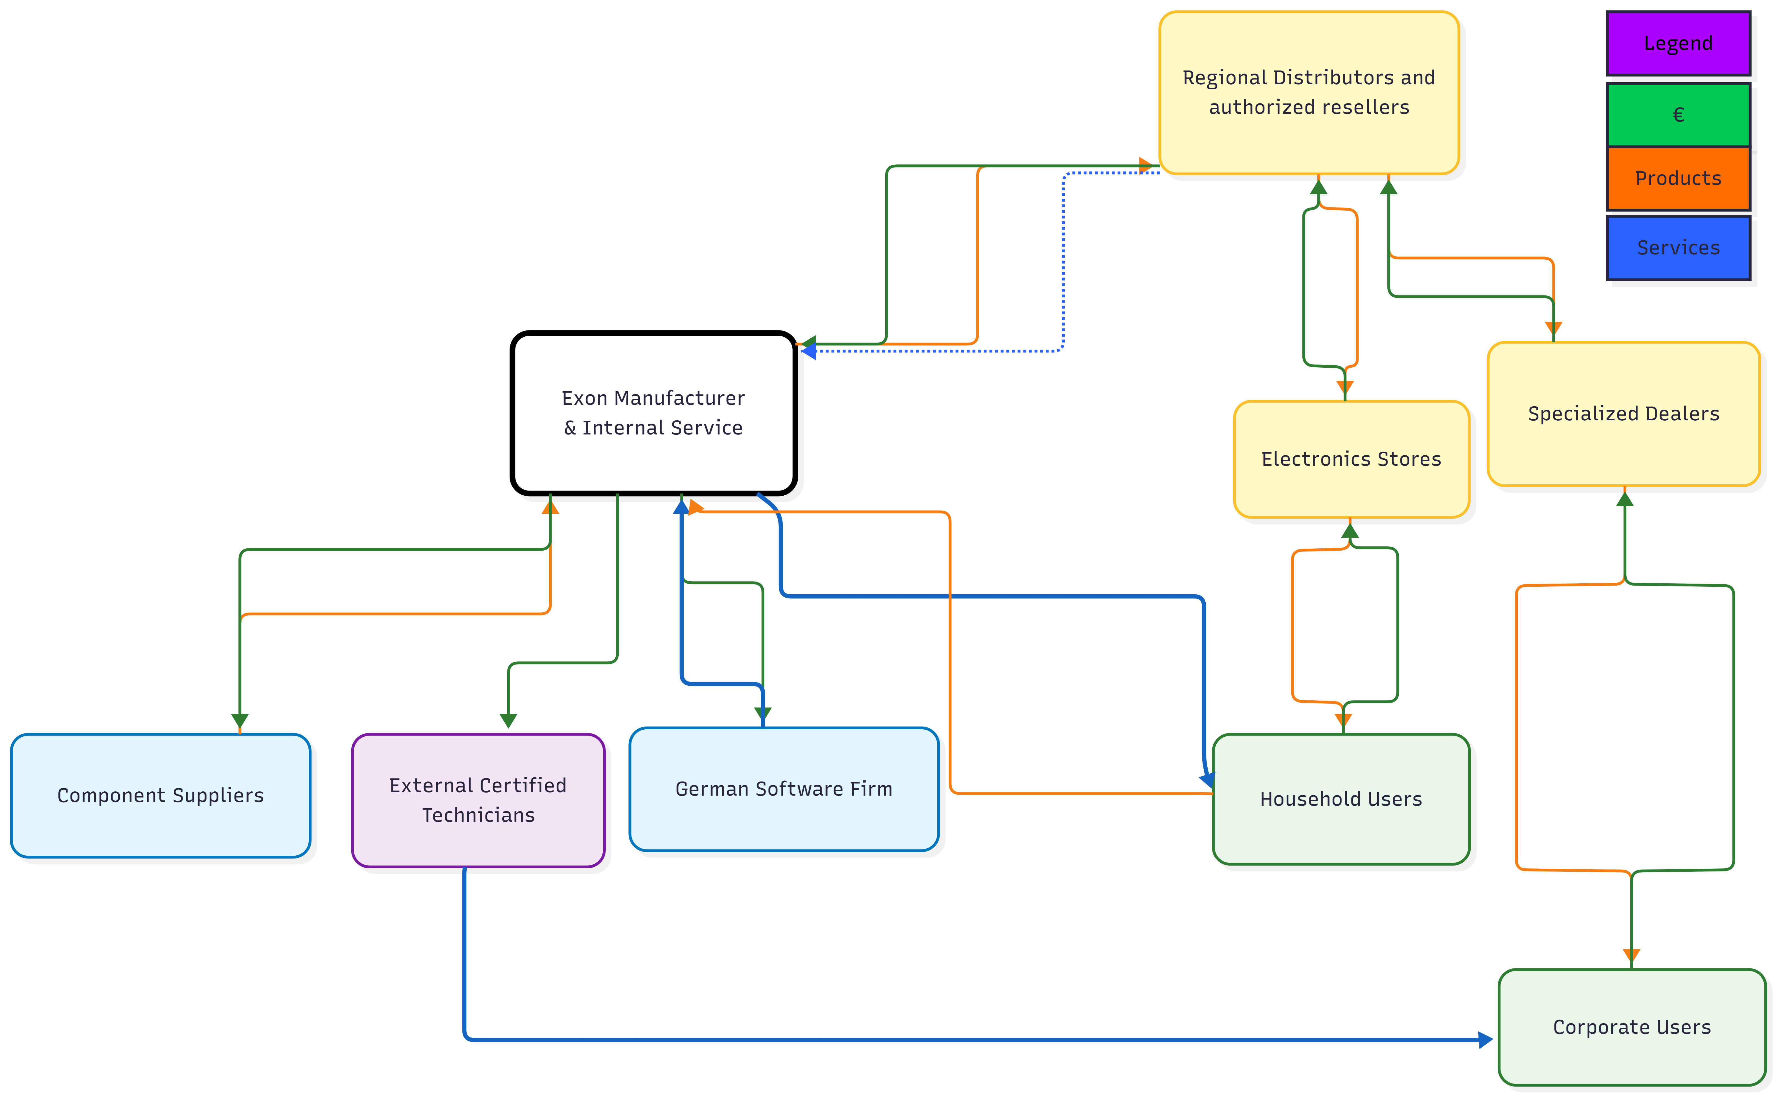
Figure 1: Exon’s current network of actors.

Selected business model patterns
Given the challenges Exon is facing, such as declining demand for printers and the absence of a sustainable end-of-life strategy, a set of business model patterns was selected to support a shift toward a more sustainable, service-oriented model. In particular, the Razor-and-Blade Pattern, mainly applied to B2B segments, allows recurring revenues through complementary products and services such as ink, paper, software, and maintenance.

To manage and scale this model, Exon can adopt a Platform-as-a-Service approach. The digital platform centralized the management of printers, usage, subscriptions, and service activities across corporate clients and shared printing locations. It also supports sustainability features, such as tracking resource consumption and facilitating take-back initiatives for empty ink cartridges.
An Experience Selling approach is proposed for household users, positioning printing as a creative activity rather than a purely functional one. Through shared printing hubs and the digital platform, users can access high-quality photo printing and personalized products, such as photobooks and custom calendars.

Exon can also apply a Freemium Model. Basic platform access would be free, while premium features generate revenue. For B2B clients, this may include a limited trial or basic service coverage before moving to paid subscription tiers. For household users, premium options include higher-quality materials and advanced customization features.

Finally, a Mass Customization model allows personalized printing while maintaining standardized, on-demand production, reducing overproduction and waste. Together, these five models support Exon’s shift from product sales to a more sustainable, service-based business model.

Full business model design

Value proposition
Exon delivers a sustainable, subscription-based printing ecosystem that bridges the gap between high-performance business needs and eco-conscious lifestyle values. For B2B clients, Exon provides tailored subscriptions that lower logistic costs and enhance brand reputation through integrated CSR projects and automated paper-use reporting. For B2C users, Exon offers an "experience-selling" platform that fosters a sharing economy and community-driven creativity, ensuring high accessibility at reasonable prices. By centering the new model on modularity and circular economy principles, Exon will empower customers to reduce their environmental footprint without sacrificing quality or convenience.

Key partners
Two types of partners support Exon’s operations: suppliers (e.g., local German software company, external photobook vendors) and third-party service providers (e.g., regional distributors, grocery stores, public institutions). Both partners ensure Exon’s sustainable business operations.

Key activities
The main daily operations for the good functioning of Exon’s processes consist of checking and shipping placed orders, procuring and managing the inventory, and maintaining a close overview of the customer service inquiries, as well as continuous communication across all parts of the supply chain.

Key resources
Two types of resources are distinguishable: tangible and intangible. Tangible resources include quality printer components, complementary products, an efficient assembly line, and capital, while intangible resources include HR know-how, marketing and communication, strong partner relationships, and reliable suppliers.

Customer relationship
Exon manages a dual-layered customer relationship strategy designed to ensure long-term loyalty and operational efficiency. In the B2B sector, the company fosters recurring relationships driven by a robust subscription-based model. While the subscription itself creates an indirect relationship, Exon maintains a direct connection through specialized maintenance services made possible by the hardware's modularity.

For B2C customers, the relationship is primarily indirect, facilitated through engagement with the online platform and its sharing ecosystem. However, a direct relationship is established whenever individual customers interact with and utilize the physical printers. This hybrid approach allows Exon to scale its digital community while providing tangible support where it matters most.

Customer segments
The target audience consists primarily of young- to middle-aged, middle- to higher-income customers in developed countries, identified through demographic, geographic, behavioral, needs-based, technographic, and psychographic segmentation. They are socially-inclined customers who use the platform frequently, with higher demands but less time, in service-heavy companies mostly in the tertiary sector, and also individuals with the motivations of self-expression.

Cost structure
The cost structure is examined by exploring all the fixed and variable costs across varying stages - including initial upfront costs, maintenance (fixed) costs, supply chain costs, and any end-of-life financial considerations.

Revenue streams
Revenue streams are described and thoroughly examine all sources of revenue, including subscription fees, complementary products, recycling and reuse benefits, as well as premiums.

Channels
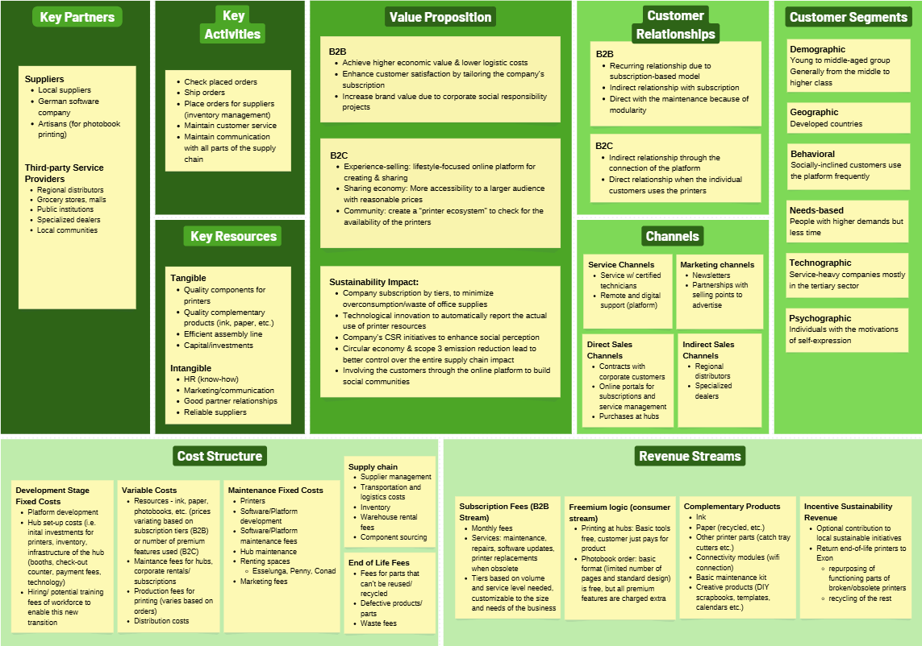
Value is delivered through a combination of digital channels, shared printing hubs, and selected B2B sales channels, allowing both corporate and household users to access printing services without owning the printers.
Figure 2: Exon´s revised Business Model Canvas

Summary of the new business model
Exon's new business model transitions from traditional hardware sales to a circular, subscription-driven ecosystem that prioritizes sustainability and the sharing economy. By offering tiered B2B subscriptions and a lifestyle-focused B2C platform, the company shifts its value proposition toward high-impact CSR initiatives and reduced resource waste. This innovative approach leverages modularity for direct maintenance and technological tracking of paper and other office supplies used to align economic growth with environmental and social responsibility.

New network of actors
Exon needs to face the reality of digitalisation and the increased environmental awareness amongst its customers, leading to reduced printer sales. The proposed business model targets this issue from two perspectives.

On one hand, the new model ensures that Exon will exercise its corporate social responsibility by shifting its attention to local suppliers and supporting artisanal producers. On the other hand, the revised activities will be more sustainable and environmentally-conscious. Indeed, the services will allow corporate consumers to minimize the quantity of waste by allowing firms to track their consumption and modify the quantity of complementaries ordered based on their actual needs. As for household users, although printing needs will never be fully eradicated, this new model will cope with the loss of printer ownership by adopting a sharing economy mindset through which access to printers is facilitated, thanks to its easy accessibility in public spaces. Additionally, Exon will be able to enlarge its service portfolio (photobooks, etc.) by leveraging its experience and accumulated know-how.

In short, the revised network of actors and activities is founded on the importance of sustainability, an aspect that speaks directly to its customers.
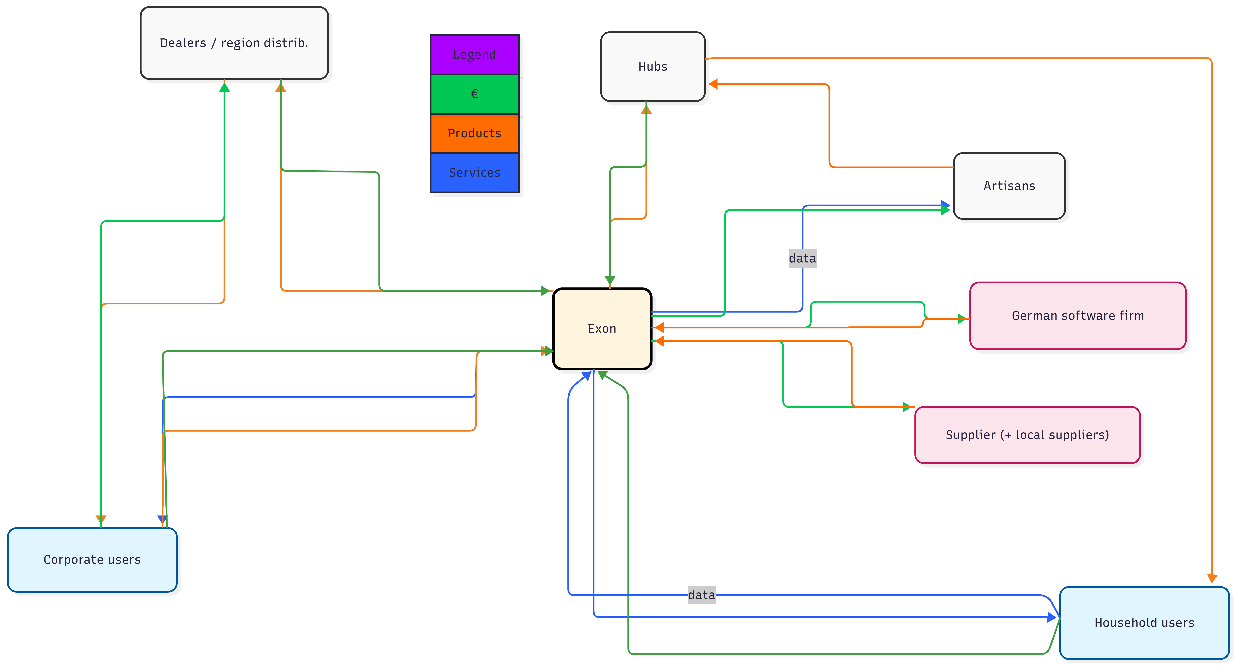
Figure 3: Exon’s revised network of actors based on the proposed business model changes.

Sustainability benefits of the new business model
Circular and sharing economy principles are a foundation for Exon’s new business model. On the B2B side, companies will be renting printers managed by Exon, meaning there's a strong incentive to maximize the printers’ use, creating modular designs and systems that allow for easier replacement and recycling, extending the corporate-grade printers’ lifespan and absorbing costs that often come with out-of-date printers and parts, which are now more efficiently changed.
On the consumer end, with Exon’s hubs, consumers are able to access high-quality printers while minimizing the waste of purchasing printers and complementaries. These high-quality printers and their increased efficiency result in far less waste from unused/broken printers, focusing instead on the printing needed at hand. This model underscores a decrease in printer needs and highlights an opportunity for a sustainable transition.

Alongside this, the hubs will support local businesses by using them for more advanced printing and other meaningful value/experiences via photobooks and other fun printing goods. Exon adds as an intermediary in this by creating a network that connects these actors and provides local and social benefits.

Potential challenges
A challenge is making the hubs easy enough for the consumer to find it equally beneficial, if not more, than having a printer at home. Therefore, the new business model relies heavily on the equal shift of its consumers. This will require a lot of initial marketing and exposure to share information about the service, highlighting its accessibility and convenience.

Similarly, with B2B printers, Exon must be able to market and communicate the value of its printer as a service as both convenient and financially beneficial. The benefits need to be emphasized so that the pros and longevity outweigh the increased pricing.

Therefore, for both B2C and B2B, the biggest hurdle will be getting consumers from both ends to join this transition, and creating exposure, as well as trust and reliability, are critical in maintaining customers.

There are also other challenges. Firstly, the initial investment/development will require significant organization and planning, as well as upfront financial costs. Furthermore, a challenge is how to mitigate the revenue transition risk of no longer selling printers directly to consumers, and instead creating a culture of shared printing.

Conclusion
The proposed business model allows Exon to leave behind traditional product sales and move towards a service-based approach that better reflects current printing needs. By relying on shared access, digital platform, and recurring services, Exon can reduce waste and still maintain a viable and competitive business model.

